Q 1 Map Reduce

hadoop jar myjar.jar AllTimeHigh cdac/NYSE.csv cdac/out50

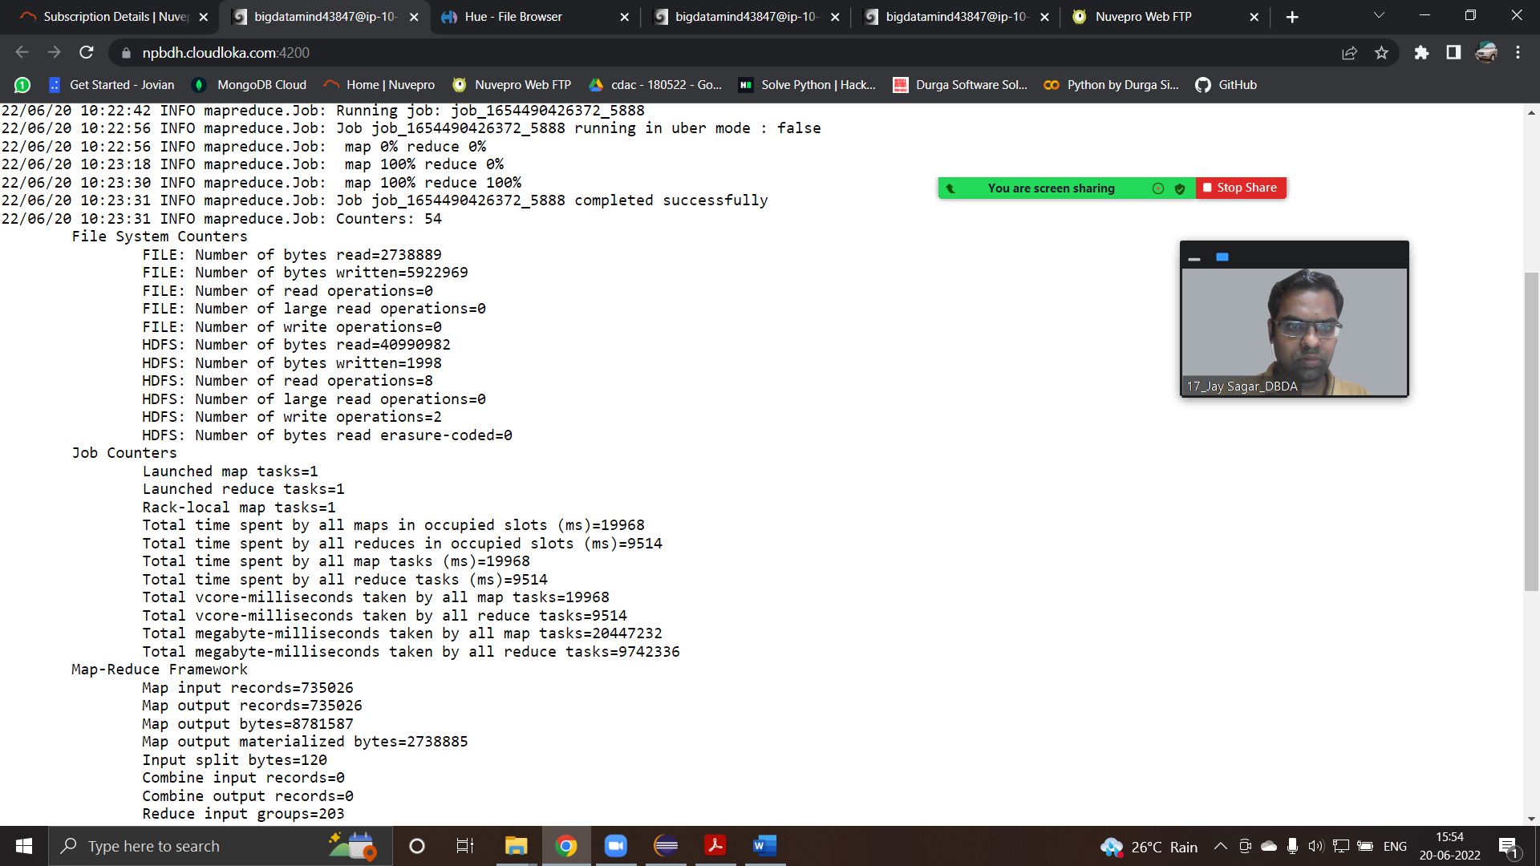

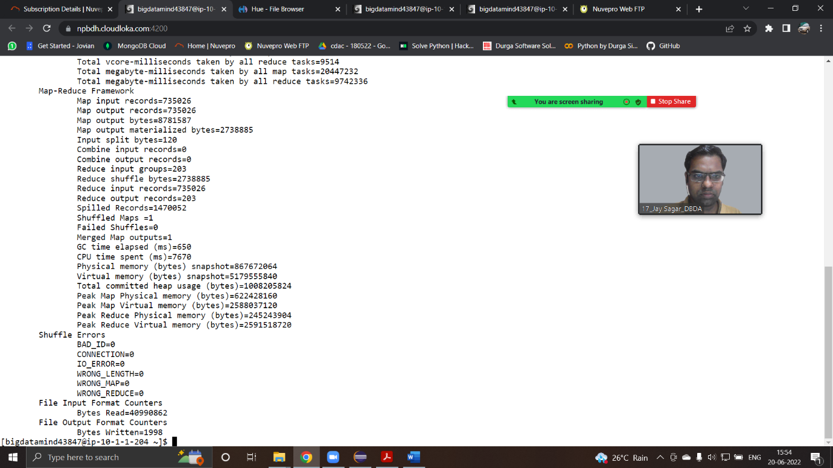

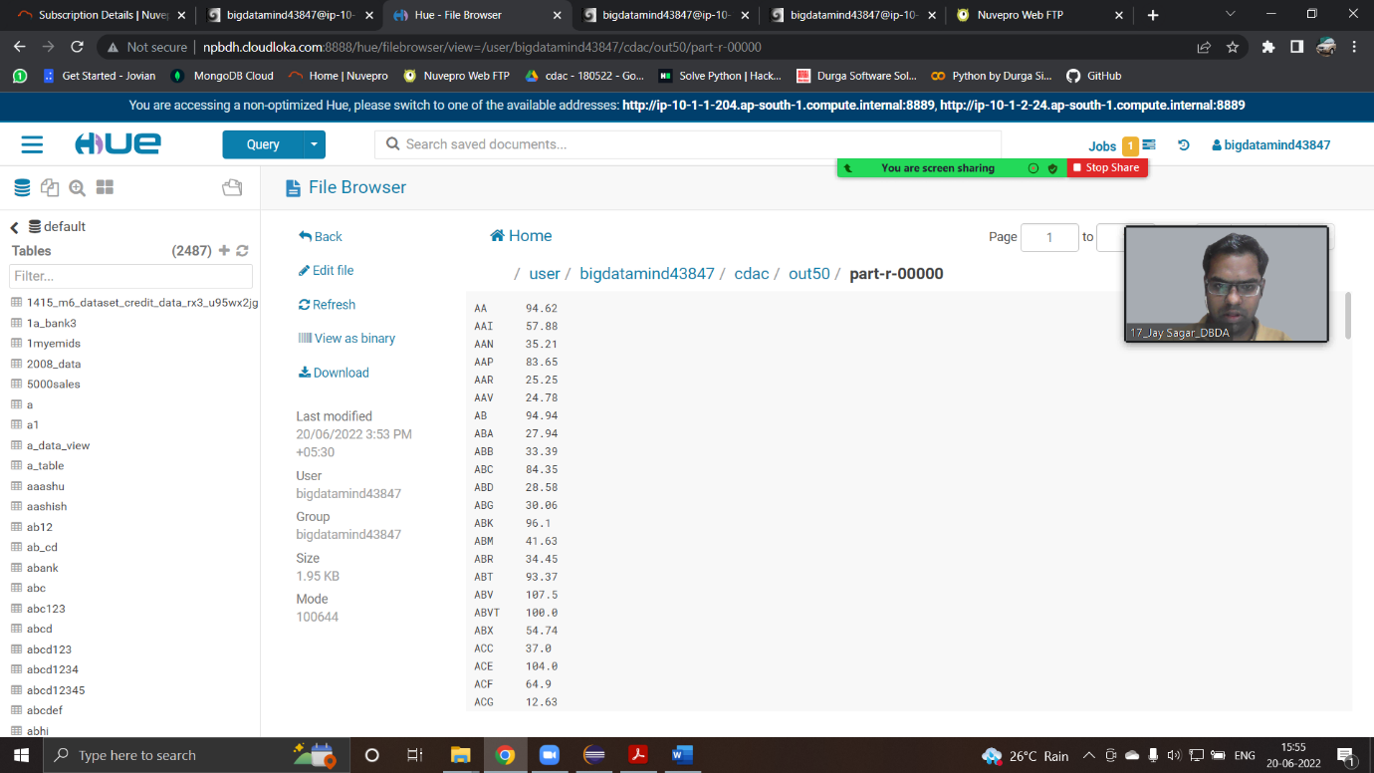

Q2 ) create external table customer(custno string, firstname

String, lastname string, age int,profession string)

row format delimited

fields terminated by ','

stored as textfile

location '/user/bigdatamind43847/custs.txt';

select profession, count(custno) as count from customer group by profession;

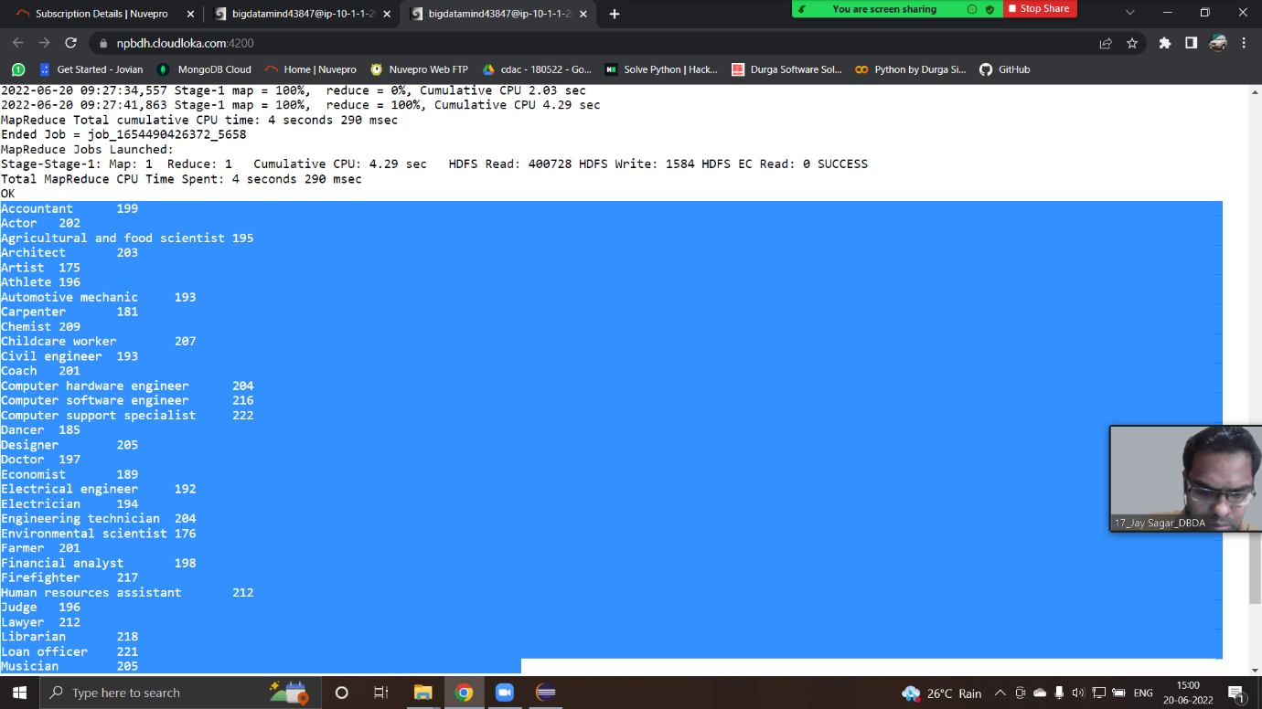



Q2 create table txnrecsByCat(txnno INT, txndate STRING, custno INT, amount DOUBLE, product STRING, city STRING, state STRING, spendby STRING) row format

delimited fields terminated by ',' stored as textfile;

LOAD DATA LOCAL INPATH 'txns1.txt' OVERWRITE INTO TABLE txnrecords;

select product, sum(amount) as total from txnrecords group by product order by total desc limit 10;

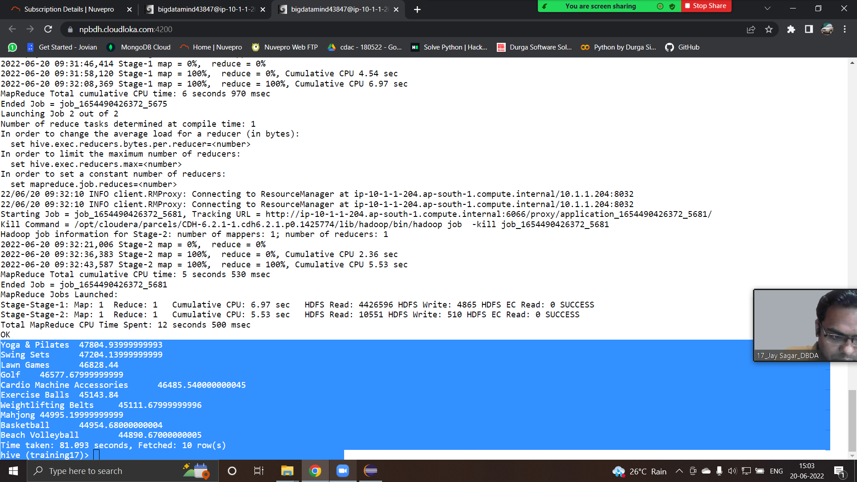

set hive.exec.dynamic.partition.mode = nonstrict;

set hive.exec.dynamic.partition = true;

INSERT OVERWRITE TABLE txnrecsByCat PARTITION(category) select txn.txnno, txn.txndate,txn.custno, txn.amount, txn.product, txn.city,txn.state,txn.spe

ndby, txn.category from txnrecords txn DISTRIBUTE By category;

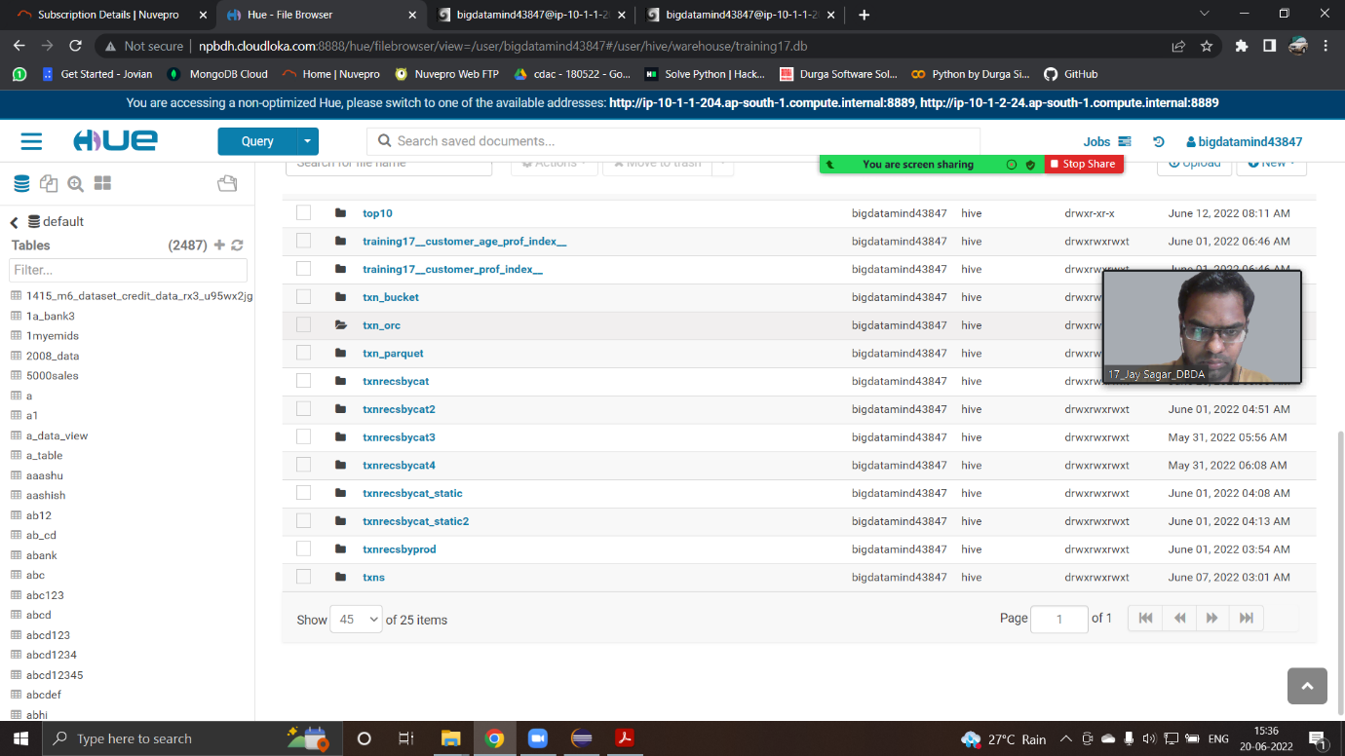

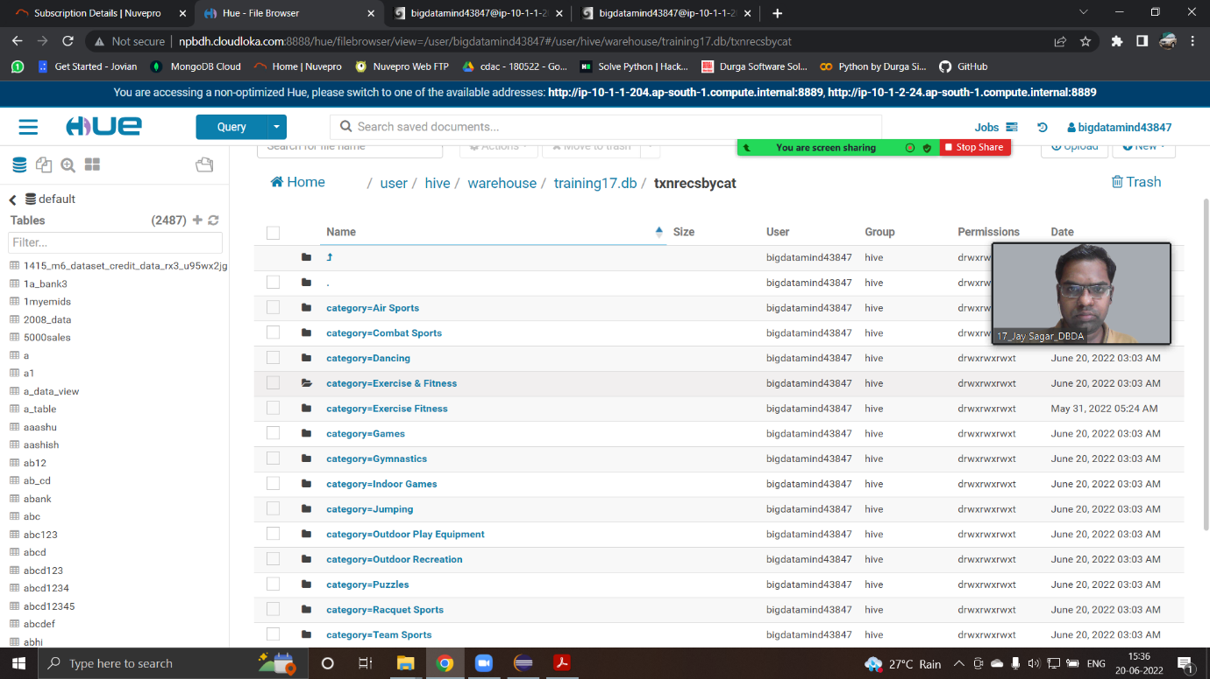

Q3

high_trav = spark.sql("select year, sum(booked_seat) as high from airlines group by year order by high desc")

>>> high_trav.show()

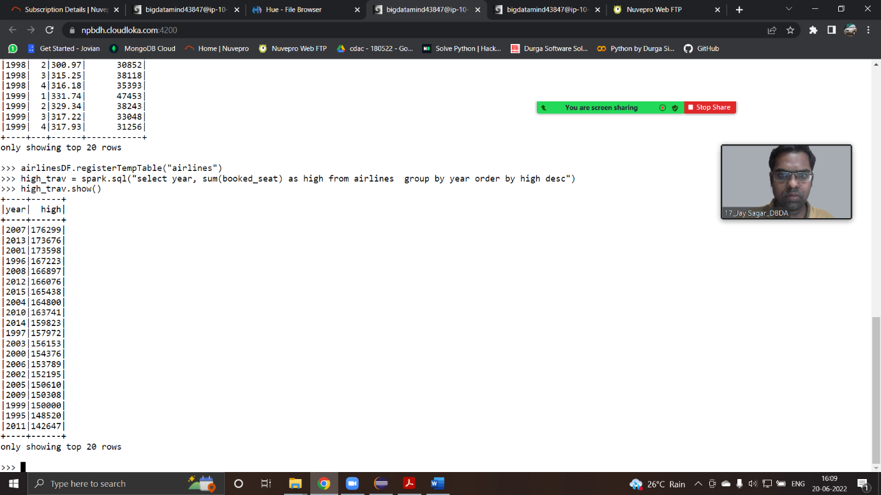

high_rev = spark.sql("select year, round(sum(arps*booked_seat)/1000000) as in_millions from airlines group by year order by in_millions desc")

>>> high_rev.show()

